
Virtual Information Night
Wednesday, September 25, 2024, 5:30-6:30 PM

Is your child a potential future CareerTech student?
Have questions about the Open House or unsure of the application process?
Do you know how to best prepare your student for acceptance?
Get answers to these questions and more!
Please register using the QR code below.

THIS SESSION is for anyone with questions about CareerTech, no matter what grade your student is in. Use the link below to join us virtually on Sept. 25th.

Join on your computer, mobile
app, or room device.
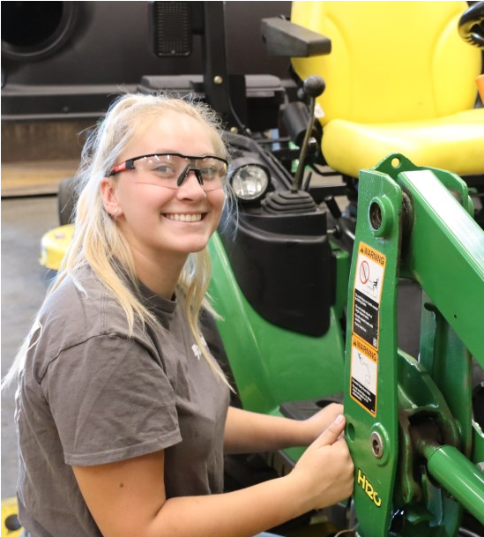
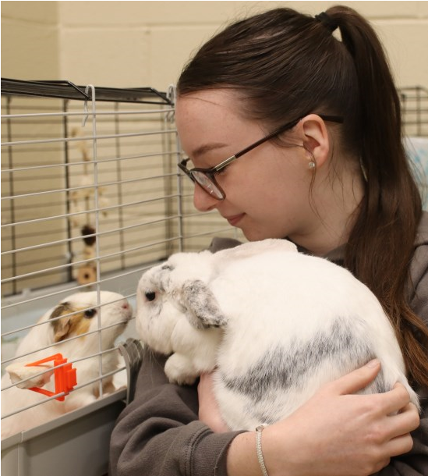
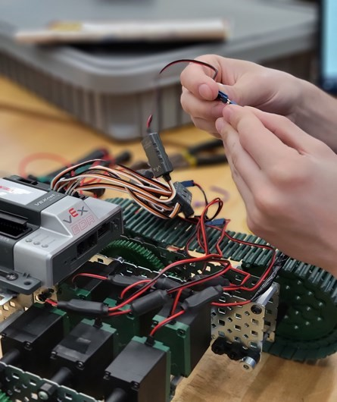
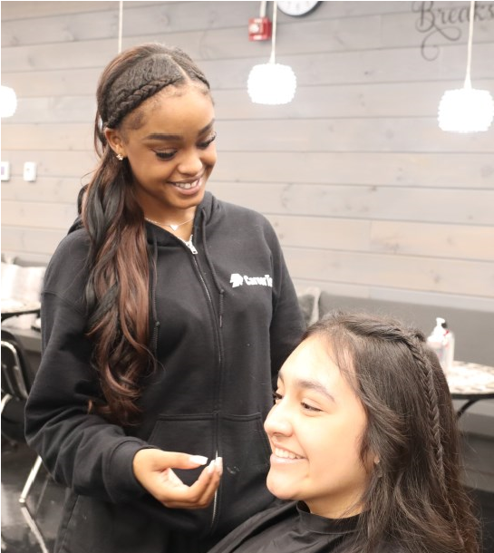
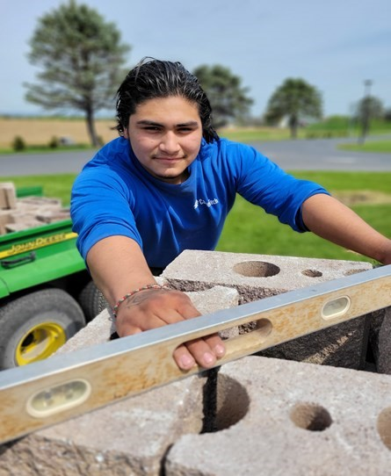
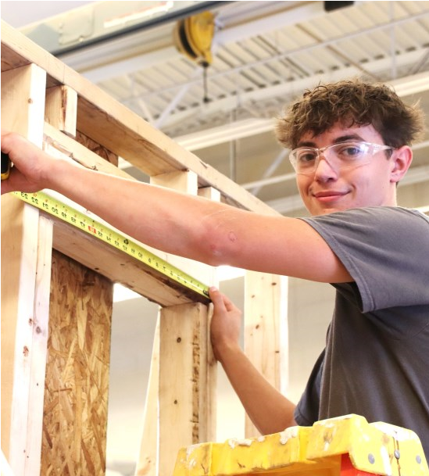
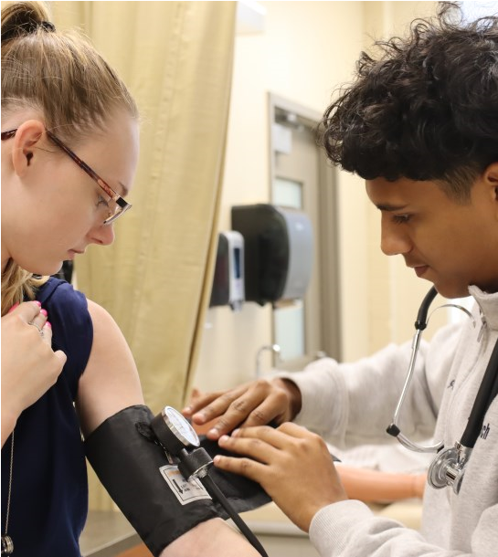

Click here to join the meeting
2463 Loop Road, Chambersburg, PA PH 717-263-9033 Fax 717-263-6568 info@franklinctc.com
The Franklin County Career & Technology Center does not discriminate on the basis of race, color, national origin, sex, disability, or age in its program and activities.

